Module 3 – Terry Inglese, October 4th, 2026

I would like to apply the 8 elements of the thought wheel to my decision to tale this course.
I am a lecturer teaching critical thinking and academic writing.

a. I would briefly define as follows:
b. In other words...
c. For example...

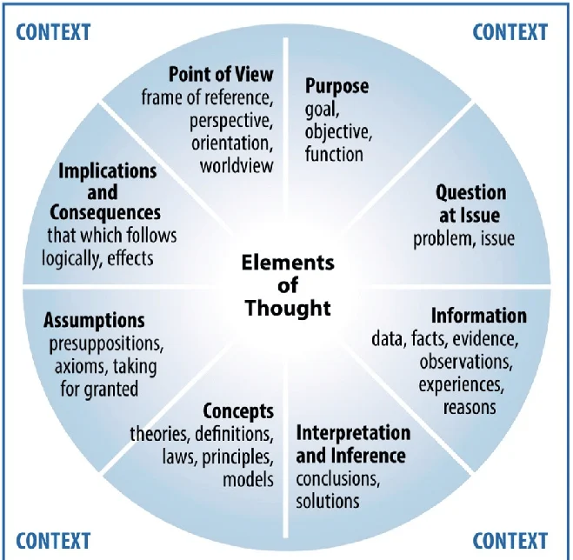

Purpose:
Even if I have already a book that I am using for teaching critical thinking, I enrolled in this module with the goal and objective to expand my knowledge on how to better teach this subject, which is very abstract.
Question/s at issue:
- How can I tackle critical thinking for teaching?
- How are the experts in this field teaching critical thinking?
- How can I model them to better teach critical thinking?
Information, experience, reason:
Because I am a very hands-on lecturer, someone who wants to transform theory into a pragmatic and concrete learning activity (I know how I teach), I would like to learn other ways of teaching critical thinking.
Inference:
By attending this module, I can enrich the contents of my teaching.
Concepts, models:
Here a concept is self-improvement combined with life-long learning. I try not to settle, in fact, I am always very unsatisfied by what I do, I want to do it better. I feel to miss out on some new didactical techniques in order to improve my work.
Assumptions:
The assumption is that I might be too unsecure or just very hungry for learning; I do not know yet.
Implications and consequences:
I appreciate learning and constant improvement; however, sometimes it feels like a never-ending endeavor; especially, now with the AI tools.
Point of view:
As an educator, I do feel that I need to try this wheel as a new didactical approach in my module. I really like it, even if I feel I need to learn it more, to master the reasoning behind it.

