Name: Lars Michael Keppler
Date: 26th August 2023

CT800: Week 1 Assignments

4)
a) “What is critical thinking”?
Critical Thinking is a cognitive skill that addresses multidimensional inadequacies in human thought with the aim to improve one’s thinking.
It is the art of improving one’s reasoning – and thereby judgment – to become a more fairminded thinker.
“Fairminded” in this regard doesn’t mean sacrificing one’s own needs or goals, but rather achieving them without the need to manipulate others in a harmful way.
To facilitate that transition, one has to accept the fact that natural and subconscious thinking is clouded with several biases, ego- or sociocentric tendencies, and can eventually cause more harm than good if left to its own devices.
There are different stages of development within that aspiration of becoming a more fairminded thinker that ultimately demands the development of intellectual character traits to fully live by the values of Critical Thinking.

b) “How is the concept of critical thinking presented in this week’s material different from conceptions of critical thinking that you have previously encountered?”
There is a subtle contrast between the definition of critical thinking in this week’s material and the conceptions of critical thinking I’ve been taught.
While the conception of critical thinking that I’ve grown up with focuses much more on the outcome of thinking, the conception of critical thinking in the provided material rather addresses the thought process itself leading to that outcome.
From my observation, the concept of critical thinking that I was taught aims to force you into line with - whatever outcome a certain group you’re in at that moment – desires.
Almost like:
“You’re thinking critically when you come to the same conclusions as the majority.”
Meanwhile, the concept of critical thinking in the material sounds like this:
“You’re thinking critically when you did your best in addressing several cognitive biases and shortcomings before making a conclusion – even if that conclusion might hurt your or other people’s feelings.”
This conception, in contrast to the definition of critical thinking I’ve grown up with, reminds me of the difference between ultimate and proximate goals.
The idea of critical thinking provided in this material is much more process-oriented (proximate) than solely focusing on the conclusion itself (ultimate).

c) “Think for Yourself Activity 1.4.”
Unfortunately, the data was not available.
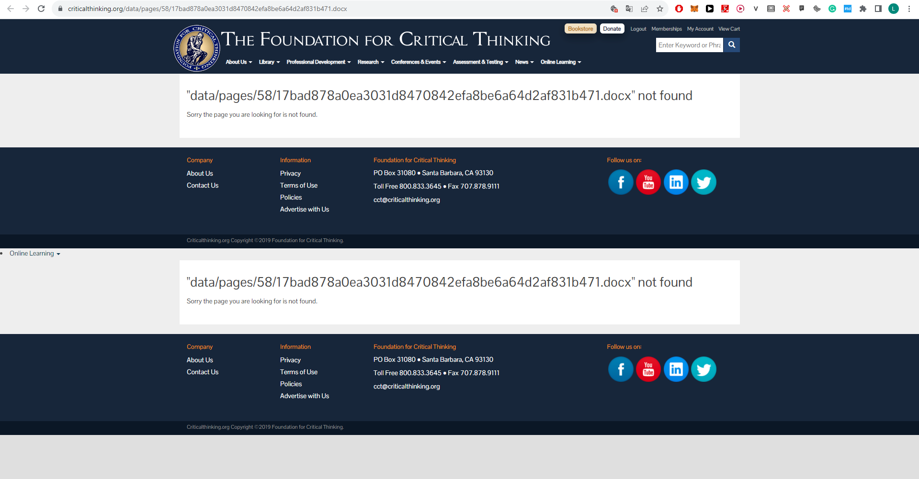

d) How I’m going to use this week’s content in my daily life to develop and apply critical thinking:
What really stood out to me were the three kinds of thinkers in the “Aspiring Thinker’s Guide”.
Due to my work in a Blockchain Laboratory and my current project to build a Personal Brand on Twitter / X, I’m both confronted with academic and non-academic people.
When having conversations with these people, I’ll try to figure out in what category of the three thinkers they fall into – as well as do my best to observe myself.
Furthermore, I will use the course’s material when contemplating the future I want for myself.
After all, approaching life in an entirely egotistical way (almost narcissistically / machiavellian) might not lead to a fulfilling life…

e) Hello, I’m Lars:
I am a 22-year-old Blockchain Researcher based in Germany who has just dropped out of university to become self-employed.
However, that does not mean that I neither value academic rigor nor self-reflective thinking. Otherwise, I wouldn’t be able to work with several academics (incl. PhDs / Profs.) in a Laboratory for Digital Innovation and Transformation that routinely publishes scientific papers...
As I’ve already posted in the forum, a popular figure in the cryptocurrency space (Charles Hoskinson) made me aware of this Foundation.
My goal is to become aware of the cognitive shortcomings our thinking has and how to improve them to not only use them in creating a fulfilling future for myself but helping others do so as well.
In my leisure time, I’m mostly found doing all kinds of sports – including Weightlifting, Kickboxing, and just recently: Dancing.
I am excited for this course and to meet my fellow students!
Cheers,
Lars

